MARYLEE G. FAIRBANKS
SAG/AFTRA AEA
Mezzo-Soprano (978) 500-4885
Height: 5’ 7” ml@maryleefairbanks.com
Hair: Grey/brown www.stagespodcast.net
Eyes: Green www.maryleegfairbanks.com

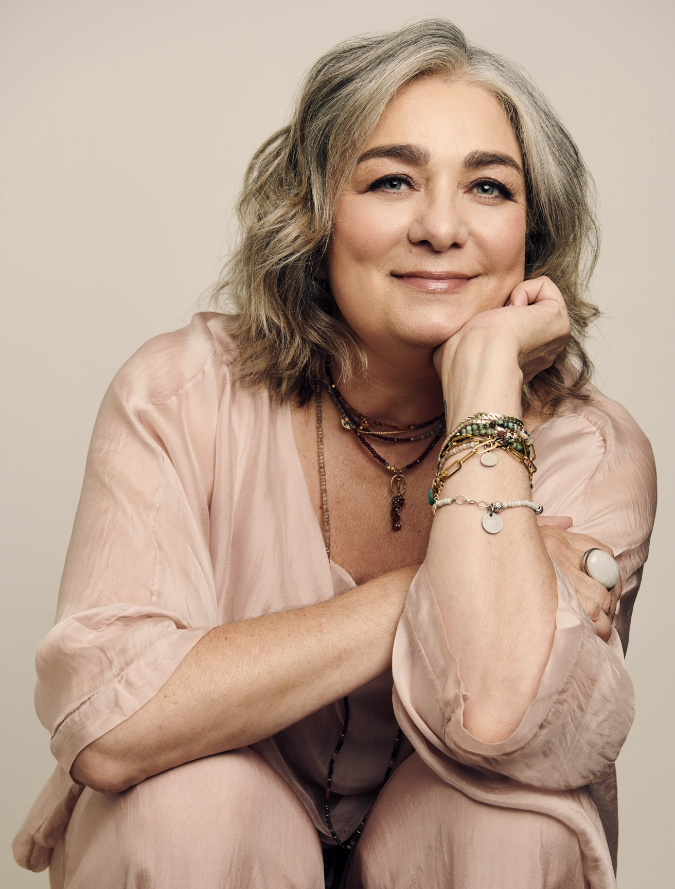

Off-BROADWAY
I LOVE YOU YOU’RE PERFECT NOW CHANGE Woman #2 Westside Theatre
New York & Boston Companies

NATIONAL TOURS
RAGTIME Mother (Perf./US) Livent
US PREMIER L.A/Vancouver
THE WILL ROGERS FOLLIES Betty Blake Troika

REGIONAL THEATER
RAGTIME CONCERT w/ Keith Lockhart Emma Goldman(cov). B.S.O (Boston & Tanglewood)
THE MUSIC MAN Mrs. Paroo Reagle Music Theatre
THE THING ABOUT MEN Lucy Am. Stage NY/Broward Ctr
COMPANY Jenny Barrington Stage Co.
JACQUES BREL.... Principle Syracuse Stage
JOHN & JEN Jen Adirondack Festival
THE WILL ROGERS FOLLIES Betty Blake Westbury Music
THE WILL ROGERS FOLLIES Betty Blake Maltz Jupiter Theater
GUYS AND DOLLS Sarah Brown Westchester B'way Theater

VOICE OVER/ RECORDINGS/COMMERCIAL
Co-Producer and Co-Host of STAGES PODCAST.
Voice over/Commercial see website www.maryleegfairbanks.com
A New Stage : Available on Itunes, Amazon
Broadway Inspirations: Varese Sarabande

EDUCATION
1988 EMERSON COLLEGE BS (Mass Communication/Theater Arts)

SPECIAL SKILLS
TONY AWARD winning Producer (STAGES PODCAST & THE OUTSIDERS)
Featured on PBS Stories From The Stage
Moth Radio Hour story slam winner
Founder Chakras Yoga Company, yoga teacher
Writer Elephant Journal, LA & Boston Yoga Magazine, Gaiam, Bliss (see website for publications)
Accents: Boston, New York dialects, Irish Brogue

